# Annexure3b- Complete filing

# INVENTION DISCLOSURE FORM

Details of Invention for better understanding:

**1. TITLE:** **Sharp U Turn Accident Safety System**

**2. INTERNAL INVENTOR(S): (INVENTORS WORKING IN LPU)**

|  |  |
| --- | --- |
| A. Full name | Dr. Prince Arora |
| Mobile Number | 9592340509 |
| Email (personal) | [princearorabca@gmail.com](mailto:princearorabca@gmail.com) |
| UID/Registration number | 28019 |
| Address of Internal Inventors | Lovely Professional University, Jalandhar |
| Signature (Mandatory) |  |

**INTERNAL INVENTOR(S)/ STUDENT(S):** All fields in this column are mandatory to be filled

|  |  |
| --- | --- |
| A. Full name | Deepak Kumar |
| ­­­­­Mobile Number | 7050795540 |
| Email (personal) | d.wizard.techno@gmail.com |
| UID/Registration number | 12220902 |
| Address of Internal Inventors | Lovely Professional University, Punjab-144411, India |
| Signature (Mandatory) |  |

**EXTERNAL INVENTOR(S): (INVENTORS NOT WORKING IN LPU)**

|  |  |
| --- | --- |
| A. Full name | Amit Raj |
| Mobile Number | 62003606628 |
| Email (personal) | goldi.aryan007@gmail.com |
| UID/Registration number | 12212172 |
| Address of Internal Inventors | Lovely Professional University, Punjab-144411, India |
| Signature (Mandatory) |  |

***For External Inventors*, NOC (No Objection Certificate) from the affiliated institute/university/Industry/lab etc. is mandatory for each individual inventor and their respective topic. For NOC, format is attached below.**

**(FOR ADDITIONAL INVENTORS, PLEASE ADD ROWS)**

**3. DESCRIPTION OF THE INVENTION:** The Sharp U-Turn Accident Safety System is a model designed to increase safety and prevent accidents at sharp turns specially to hill’s areas. Heart to the system are four IR sensors, two Ultrasonic sensors, six led and two lcd. IR senor and Ultrasonic sensor are positioned in such a way along the road so that it continuously scans for approaching vehicles or obstacles and its types. It monitors the motions of vehicles and it gives the information to opposite side road vehicle drivers, upon detecting an object, the system initiates a series of responsive actions for the prevention of accident and alert both side the drivers.

The critical features of system are IR sensor and Ultrasonic sensor, the IR sensor which detects the moving objects and it gives the information to Esp8266 that process it and give turn on the specific type of led lights. The Ultrasonic sensor will calculate distance and speed of objects and transmit the information to esp8266 chip and then transfer it to LCD display to prompt the message clearly.

There are three types of led to help the diver to take precaution or take necessary action: -

1. **Green Led:** As shown in figure6, the green led will always glow and it will indicate the both side of road the when there will no vehicle on the road or the heavy vehicle or small vehicle or no object is detected through IR sensor like truck so, green will always glow when road will be completely free.
2. **Orange Led:** As shown in figure5, the yellow led will glow when small vehicle detects by first IR sensor it will indicate the both side of road the when there is small vehicle or small object vehicle on the road so, it will alert the individuals at another end of the road about the information of another side vehicles to prevent the accidents and driver will take necessary action in meantime.
3. **Red LED:** As shown in figure4, the red led will glow when big or heavy vehicle detects by second IR sensor it will indicate the both side of road the when there is heavy vehicle or large object on the road so, it will alert the individuals at another end of the road about the information of another side vehicles to prevent the accidents and driver will take necessary action in meantime.

As shown in figure3, the Ultrasonic Sensor has been used to detect the moving vehicles and take measure the distance and calculate the speed of the upcoming vehicle or object it will continuously take measure and send data to control unit esp8266 and control unit will send data to lcd display and show the result.

1. **PROBLEM ADDRESSED BY THE INVENTION:**

The Sharp U-Turn Accident Safety System model finds the information about possibility of the accident and increase the driver’s awareness so that prior to the accident driver can take a feasible step to prevent accidents:

1. **Visibility Limitations and awareness:** At the Curve Road individual drivers don’t have visibility of another side. In that case it increases visibility and awareness of drivers so that they can take action by just looking at the led colour and also LCD that shows the required information about the other side vehicles.
2. **Detection of vehicles:** It detects the vehicles that are hidden from views.
3. **Reaction Time:** Drivers will have enough reaction time to react and to take the appropriate action to prevent the accident
4. **Information Overload:** In the absence of clear, immediate information about potential hazards, drivers may not make timely decisions to avoid accidents, especially in high-stress situations.
5. **Inconsistent Alert Levels:** We can say it is the unique feature of the model it differentiates the vehicles type coming towards him and it alerts the drivers according to the vehicles like Red Led glows when vehicles will be larger like Trucks, Buses etc and it’s the Higher Alertness Level, Orange Led will glow when there will be smaller vehicles like Cars, Motorcycles etc that is medium level alertness and Green Led will glow when road is free
6. **OBJECTIVE OF THE INVENTION**

The Sharp U turn safety system model achieves the following objectives by processing some detect information:

1. **Real-Time Accident Detection**:
   * IR sensors will continuously detect the moving objects and pass the information to central unit esp8266 and then it will glow the led on the basis of the object size. According to information it measures the accident potential.
   * According to the accident potential it alerts the drivers to prevent the accidents.
2. **Accident Prevention**:
   * The ultrasonic sensor will continuously measure the speed of the vehicle and display the information on LCD so that accident can be prevented.
3. **Enhanced Driver Awareness**:
   * Using three-color LED system, to pursue the level of alertness required:
     + Red Led for larger vehicles like Bus, Trucks etc alerting the highest chances of accident.
     + Orange Led for smaller vehicles like Motorcycles, Cars etc alerting the medium chances of Accidents.
     + Blue Led gives the signal to drivers that road is clear you are free to go.
   * Showing Alertness level can ensure the drivers how much can have to be alert.
4. **Safety for All Road Users**:
   * Reduce the collision of vehicles.

**C. STATE OF THE ART/ RESEARCH GAP/NOVELTY:** Describe your invention fulfil the research gap?

|  |  |  |  |  |
| --- | --- | --- | --- | --- |
| Sr. No. | Patent I’d | Abstract | Research Gap | Novelty |
|  | US10392013B2 | Collision detection and avoidance system  The images are projected either as flat images on the roadway or three-dimensional (holographic) images. The occurrence and severity of a collision is defined by the rate of change in dimensions of the projected images that exceeds a predetermined value corresponding to a deceleration or acceleration of more than 1.1 g. Collision data measured by vehicle or extra vehicular (such as GPS) sensors are instantly stored and transmitted to the police department and emergency medical services.  • Projects flat or three-dimensional (holographic) images on the roadway.  • Collision detection based on the rate of change in dimensions of the projected images.  • Collision data transmission to authorities using vehicle or extra vehicular sensors. | 1. Gap: The first patent focuses on projecting images and using collision data, while the second patent uses IR Sensors for vehicle detection and type identification. 2. Gap: The first patent uses image projection changes to measure collision severity, but it lacks detailed vehicle speed and type information which can be crucial for accurate analysis. 3. Gap: The first patent transmits collision data to authorities but does not mention real-time driver feedback. The second patent provides real-time visual feedback but lacks an automated reporting system. 4. Gap: The second patent focuses on LED and LCD displays for vehicle status but does not explore advanced visualization techniques like holography. | 1.Combine both technologies to enhance vehicle detection accuracy and provide a more comprehensive situational awareness system. This could involve using IR Sensors to detect vehicles and project relevant warning images or holograms on the roadway.  2. Integrate speed and vehicle type data from the second patent to refine collision severity analysis, providing more precise and actionable data to emergency responders.  3. Develop a unified system that provides real-time feedback to drivers and simultaneously transmits critical data to authorities. This could enhance both immediate driver response and post-accident emergency services.  4. Explore advanced display technologies, such as augmented reality (AR) or holography, to provide more intuitive and immersive driver alerts and information displays. |

**D. DETAILED DESCRIPTION:** The Sharp U-Turn Accident Safety System has been designed to increase safety at sharp U-turns, addressing issues related to visibility, accident prevention and real-time monitoring status of road. This model having a combination of sensors, displays, and alert mechanisms to provide a solution for preventing accidents and improving road safety. Below is a detailed description of the model’s technical functionality and components:

**1. System Overview:**

The Sharp U-Turn Accident Safety System model is a combination of many components working in together to monitor the road status, detect potential accidents and provide real-time alerts to drivers. The main components of the system are four IR sensors, and two LCD display, three coloured LEDs, two Ultrasonic Sensor and Esp8266 working as a control unit.

**2. IR Sensors:**

* **Positioning of IR Sensor: As shown in Figure3,** two IR sensors has been placed at the different height so that it can differentiate the type of vehicles since it having the fixed range means first IR sensor or Sensor A will be placed on one or two feet of the road because small vehicle maximum size is five to six feet so any vehicle or object can be easily detected and second IR sensor will be placed on ten feet so it detects heavy vehicle like truck or bus, So Both IR sensor have been used for both vehicles types larger and smaller.
* **Detection Mechanism:** It emits the infra-red signal to detect the obstacle.
* **Data Collection:** Using IR Sensors, it gathers the required information and after processing it gives the appropriate warnings to the drivers.

**3. LCD Display:**

* **Functionality:** As shown in figure3, the LCD displays required information received from Esp8266(control unit) like distance, speed from ultrasonic sensors.
* **User Interface:** It changes monitored information at real-time and display clearly and understandable format.

**4. Three Colour Led Indicators:**

* **Red LED: As shown in figure3,** it glows when the model detects a large vehicle or a high-risk situation. The red Led provides a high-alert warning to both side drivers for the immediate caution.
* **Orange LED: As shown in figure3,** it Glows when a smaller vehicle is detected or in medium-risk scenarios. This Led indicates that drivers should be aware but do not necessarily need to take urgent action.
* **Green LED: As shown in figure3,** indicates that the road is clear and obstacle free. There is no need to take any type of action

**5. Ultrasonic Sensor:**

* **Ultrasonic Sensors:** As shown in figure3, it continuously measures the distance and speed of coming vehicles to analyse the accident level.

**6. Central Unit Nodemcu Esp8266:**

* **Esp8266:** As shown in figure3, the Esp8266 is the central processor of the system, responsible for receiving data from the IR sensors, processing it, and controlling the LCD display and LED indicators.

**E. RESULTS AND ADVANTAGES:**

**1. Results:**

1. **Enhanced Hazard Detection:**
   * The Sharp U-Turn Accident Safety System demonstrates improved hazard detection capabilities compared to traditional safety measures. The IR sensors provide accurate and real-time detection of approaching vehicles and obstacles, even in low-visibility conditions.
2. **Real-Time Alerts and Information:**
   * The Model continuously delivers real-time alerts to drivers through a combination of coloured LEDs and an LCD display. This real-time information helps the drivers to analyse the upcoming accidents.
3. **Reduction in Accidents:**
   * Initial implementation and testing have shown a significant reduction in accident rates at sharp U-turns where the system is installed. This Model minimize the accidents risk and increase the safety of drivers before accidents become crucial.
4. **Improved Driver Response:**
   * Drivers benefit from clear and immediate information regarding the speed and distance of approaching vehicles or obstacles. This allows for better assessment of the situation and timely responses, leading to safer driving practices.

**2. Advantages:**

1. **Enhanced Safety:**
   * The system's advanced IR sensors and real-time data processing provide superior hazard detection and warning capabilities. This leads to a safer driving environment by effectively alerting drivers to potential dangers before they become critical.
2. **Clear and Actionable Alerts:**
   * The use of coloured LEDs and an LCD display ensures that warnings are both visible and informative. The LED indicators clearly differentiate between high, medium, and no alert levels, while the LCD display provides detailed information on vehicle speed and distance, facilitating better decision-making.
3. **Cost-Effective Solution:**
   * The Sharp U-Turn Accident Safety System is designed with cost-effectiveness in mind. All the components used in this model having low cost that makes whole model in low budgets. As to differentiate the vehicles type, we need a CCTV camera but applying some hack of position of IR sensor, we are able to differentiate the vehicles type
4. **Ease of Installation and Maintenance:**
   * The system is straightforward to install and maintain. The components are designed for easy integration into existing road infrastructure, and routine maintenance is minimal. This reduces both initial setup costs and long-term upkeep expenses.

**F. EXPANSION:**

To ensure comprehensive protection and coverage for the Sharp U-Turn Accident Safety System, several key variables and components should be considered in the patent application. These variables encompass both the technical aspects of the system and its potential adaptations or enhancements. Here is an outline of the essential variables:

**1. Sensor Variations:**

* **Type of Sensors IR and Ultrasonic sensor:** Although infrared and ultrasonic sensors are the main components of the project, other sensor technologies (such as laser sensor and ultrasonic sensors) that could be used to accomplish comparable detection capabilities should also be discussed.
* **Both Sensor Range and Sensitivity:**  Detection performance can be impacted by a sensor's range and sensitivity. To handle varying road conditions and safety standards, coverage should incorporate variances in sensor specifications.

**2. Alert Mechanisms:**

* **LED Variations:** This Model can cover different types of LED indicators (e.g., multiple colours, different intensities) and their specific roles in alerting drivers while these three colours have chosen according to symbol of dangers.
* **Alternative Warning Systems:** We can integrate a sound system according to the level of alertness.

**3. Display Options:**

* **LCD Display:** We can also use another type of visual components like LCD to give the clear view and easily observable**.**

**4. Control Unit Configurations:**

* **Processing Capabilities:** Variations in the processing power and architecture of the control unit that manage data from sensors and control alerts should be included.
* **Communication Interfaces:** Different communication protocols and interfaces (e.g., wired, wireless, IoT connectivity) for integrating the control unit with sensors and displays should be covered.

**5. Installation and Calibration:**

* **Installation Methods:** Various methods for installing the sensors, displays, and control units, including mounting options and integration with existing road infrastructure, should be detailed.
* **Calibration Procedures:** Different calibration techniques and adjustment mechanisms for optimizing sensor accuracy and system performance should be included.

**6. Safety and Compliance:**

* **Safety Benchmarks:** Compliance with significant security guidelines and controls, counting those particular to street security frameworks and electronic gadgets.
* **Regulatory Requirements:** Adherence to local, national, or international regulatory requirements for the deployment and operation of road safety technologies.

**7. Remotely Accessible:**

* **User Interface:** We can also give the Drivers to the remotely access of data displayed on some user interface gathered by the sensors.
* **Feedback from users:** Make a feedback section so that user can provide some feedback to enhance the functionality.

**8. Expansion and Scalability:**

* **Scalable Designs:** Options for scaling the system to larger or more complex road networks, including modular components or networked systems that can be expanded as needed.

By addressing these variables, the patent will cover a broad range of potential implementations and adaptations of the Sharp U-Turn Accident Safety System, ensuring that various configurations, technologies, and use cases are included within the scope of protection.

**G. WORKING PROTOTYPE/ FORMULATION/ DESIGN/COMPOSITION:**

**1. Working Prototype Overview:**

As shown in Figure3, the working prototype of the Sharp U-Turn Accident Safety System is designed to demonstrate the core functionalities of the invention. The prototype integrates IR sensors, ultrasonic sensor and LCD display, coloured LEDs, and a control unit to provide real-time hazard detection and alerts. The following sections outline the design, composition, and working principles of the prototype.

**2. Design and Composition:**

**Circuit diagram**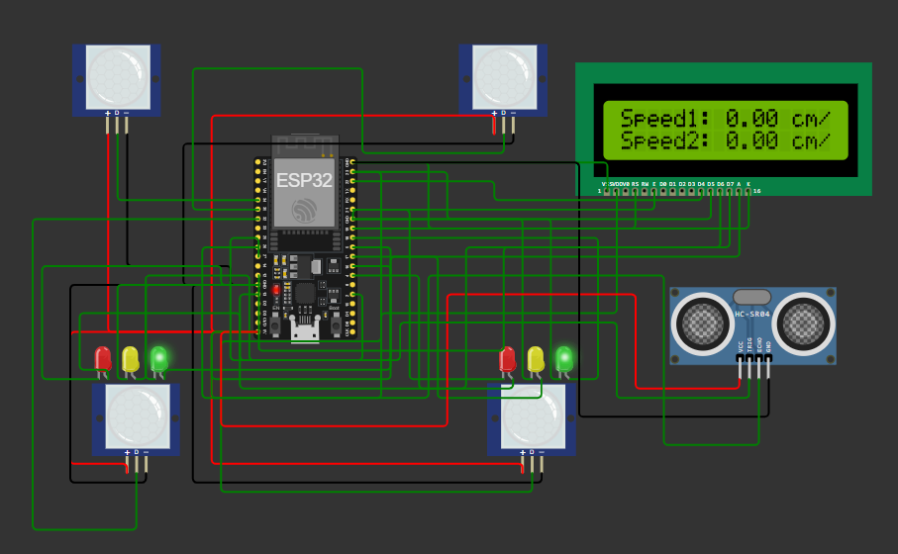

Figure 1 Circuit Diagram

**Data flow diagram**

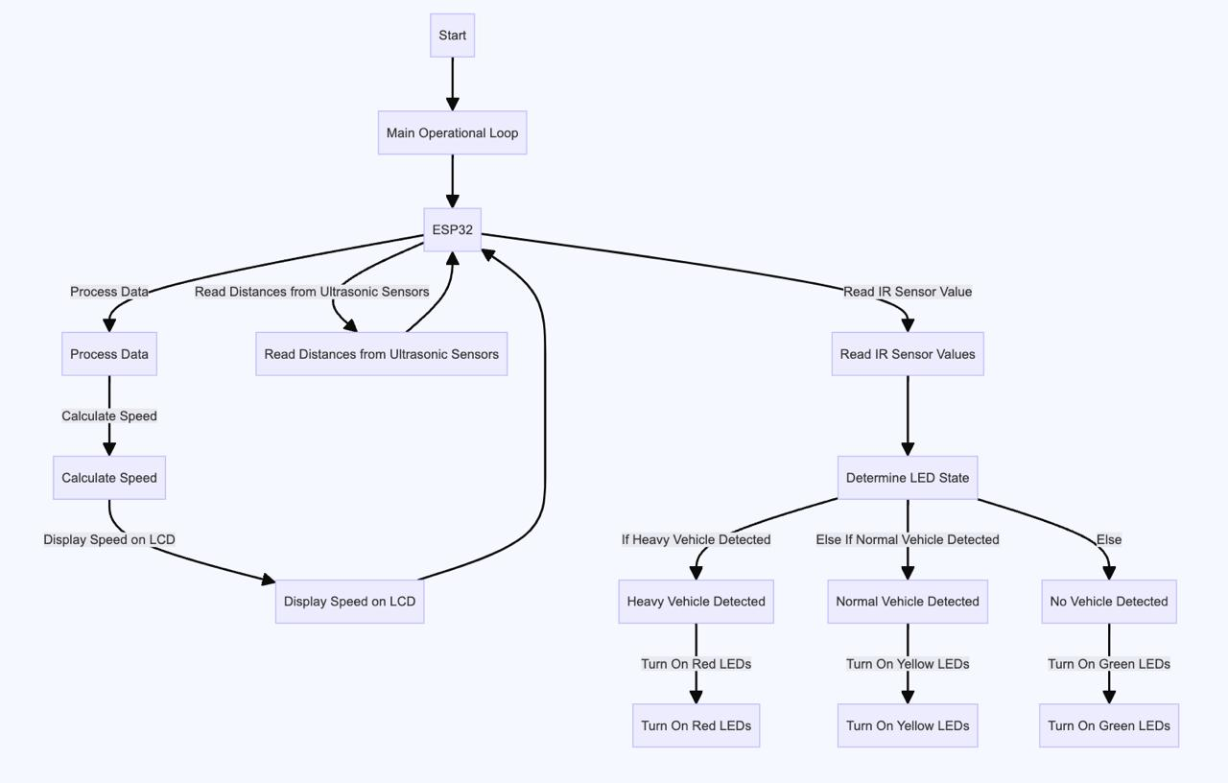

Figure 2 Data Flow Diagram

**Working prototype**

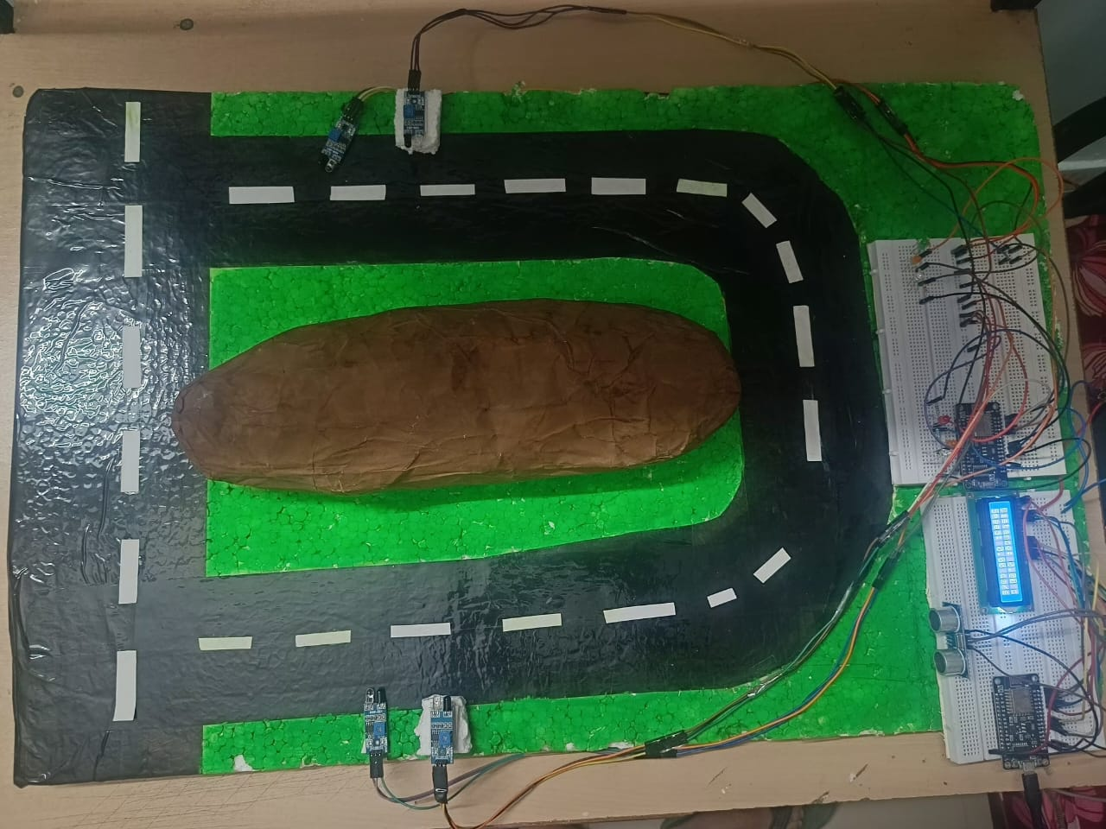

Figure 3 Working Prototype

**a. IR Sensors:**

* **Components:** As shown in figure3, the prototype uses Two IR sensors has been placed at the different height so that it can differentiate the type of vehicles since its having the fixed range. Both IR sensor have been used for both vehicles types larger and smaller. Each sensor uses an infrared to detect the obstacle.
* **Placement****:** first IR Sensor detects the smaller vehicle so it will be positioned on vehicle size so that when Sensor A detects object it will send notification to Esp8266. And   
  let IR Sensor B it will placed on ten feet, it detects the larger vehicle so it will be positioned at the height of larger vehicles since larger vehicles height is more than smaller vehicles due to this smaller vehicles cannot be detected by Sensor B. in this way we can differentiate the both type vehicles

.

**b. LCD Display:**

* **Components:** As shown in figure3, The LCD display is a standard character display. It also called as Liquid Crystal Display. Its having many variation like 16*2, 20*4 etc. it uses special type of liquid to display the character.
* **Function:** The display prompts real-time data received from the Ultrasonic sensor like speed and distance of detected objects.
* **Integration:** LCD has been directly connected through Esp8266 to pass the information show that lcd can display in proper way.

**c. Coloured LEDs:**

* **Components:** As shown in figure3, Three LEDs (Red, orange, and blue) are utilized to show distinctive caution levels.
* **Function:**
  + **Red LED:** As shown in figure4, Red Lights up when a large vehicle or high-risk situation is detected, indicating a high-alert status.

Figure 4

* + **Orange LED:** **:** As shown in figure5, Illuminates when a smaller vehicle or medium-risk situation is detected, indicating a medium-alert status.

Figure 5

* + **Blue LED:** As shown in figure 6, Lights up when the road is clear, indicating no immediate hazards.

Figure 6

* **Integration:** The LEDs are connected to the control unit, which activates them based on the processed sensor data.

**d. Control unit Esp8266:**

* **Components:** As shown in figure3, Esp8266 is a low cost micro controller having inbuilt wi-fi and Bluetooth we can also use Arduino because in this model we don’t need of Bluetooth or wi-fi.
* **Function:**
  + **Data Processing:** Receives data from the IR sensors and processes it to determine the type and distance of detected objects.
  + **Alert Management:** Controls the activation of LEDs and updates the LCD display based on the processed data.
  + **Communication:** Manages communication between the sensors, display, and LEDs, ensuring synchronized operation.

**3. Working Principles:**

1. **Detection and Measurement:**
   * As shown in figure3, IR sensors continuously detects the object of upcoming vehicle send the data to the esp8266 to for further process.
   * let Sensor A detects the smaller vehicle so it will be positioned on vehicle size + range-1 so that when Sensor A detects object it will send notification to Esp8266. And let Sensor B detects the larger vehicle so it will be positioned at the height of larger vehicles size+ range-1 since larger vehicles height is more than smaller vehicles due to this smaller vehicle cannot be detected by Sensor B. in this way, we can differentiate the both type vehicles.
2. **Data Processing:**
   * The control unit receives data from the IR sensors and analyses it to determine the size and proximity of detected objects.
   * Based on the analysis, the control unit categorizes the detected objects as high-risk, medium-risk, or clear.
3. **Alert Generation:**
   * The control unit activates the appropriate LED indicators based on the risk level:
     + **Red LED:** High alert for large vehicles or immediate hazards.
     + **Orange LED:** Medium alert for smaller vehicles or moderate risk.
     + **Blue LED:** Clear road with no immediate hazards.
   * Simultaneously, the control unit updates the LCD display with real-time information about the detected objects' speed and distance, as well as the current alert level.
4. **User Interaction:**
   * Drivers and pedestrians receive visual warnings from the LEDs and detailed information from the LCD display.

5. **USE AND DISCLOSURE (IMPORTANT):** Please answer the following questions:

|  |  |  |
| --- | --- | --- |
| A. Have you described or shown your invention/ design to anyone or in any conference? | YES ( ) | NO (√) |
| B. Have you made any attempts to commercialize your invention (for example, have you approached any companies about purchasing or manufacturing your invention)? | YES ( ) | NO (√) |
| C. Has your invention been described in any printed publication, or any other form of media, such as the Internet? | YES ( ) | NO (√) |
| D. Do you have any collaboration with any other institute or organization on the same? Provide name and other details | YES ( ) | NO (√) |
| E. Name of Regulatory body or any other approvals if required. | YES ( ) | NO (√) |

5. Provide links and dates for such actions if the information has been made public (Google, research papers, YouTube videos, etc.) before sharing with us.

6. Provide the terms and conditions of the MOU also if the work is done in collaboration within or outside university (Any Industry, other Universities, or any other entity).

7. Potential Chances of Commercialization.

The Sharp U-Turn Accident Safety System has several factors that contribute to its potential for successful commercialization. These factors include market demand, technological advantages, cost-effectiveness, and scalability.

Here’s is some bullet points of the commercialization potential:

* **Growing Safety concerns**: Today days there is many accidents are happening on the hills area so this project will help to improve the traffic management and also help the system to addresses a critical safety issue at sharp U-turns, which are common locations for accidents.
* **Insurance Industry Interes**t: Insurance companies are more interested in technologies that reduce accident rates. This system will attract interest from insurers looking to incentivize safer driving behaviours.
* **Low-Cost Components:** This prototype uses cost-effective components, including IR sensors, Ultrasonic sensor, LEDs, and LCD displays. This helps keep the production costs low and makes the system affordable for many users and government.
* **Budget-Friendly Solution:** Given its cost-effective design, this project is accessible to both small and large-scale projects, making it feasible for deployment in various settings, including residential, commercial, and public infrastructure.
* **Superior Performance:** Compared to existing solutions in these days, such as passive warning signs or basic alert systems, this project the Sharp U-Turn Accident Safety System offers superior detection and alert capabilities. This competitive advantage can attract interest from both government and private sector clients.
* **Innovative Features:** This project shows or give result in real-time data processing and multi-tiered alert system by using different sensors like IR sensor, Ultrasonic Sensor and indicate the threat level with the help of led and lcd by showing the necessary result. And also provide a unique value proposition, distinguishing it from other safety technologies in the market.
* **Government Contracts:** Opportunities exist for partnerships with government agencies and municipal authorities responsible for road safety. These collaborations could facilitate large-scale deployments and funding support.
* **Technological Enhancements:** Continued development and integration of advanced features, such as AI-based hazard prediction like connect it with blink it app or connectivity with smart city infrastructure, can further enhance the system’s appeal and market potential.

8. List of companies which can be reached for commercialization at the side the site connects.

For this model the ideal customer can be the company who is having vehicle safety, sensor production, automatic vehicles production:

1. **Bosch**
2. **Continental AG**
3. **Delphi Technologies**
4. **Denso Corporation**
5. **Valeo**

9. Any basic patent which has been used and we need to pay royalty to them.

10**. FILING OPTIONS:** Please indicate the level of your work which can be considered for provisional/ complete/ PCT filings (Mandatory to mention).

11. **KEYWORDS:**

Sharp U turn accident safety system by using IR sensor and Ultrasonic sensor

Sharp curve accident safety system in hills stations or areas

Sharp U turn accident safety system and decrease traffic in hills areas

Sharp curve accident safety system and decrease traffic in hills areas

**NO OBJECTION CERTIFICATE**

This is to certify that University/Organization Name or its associates shall have no objection if Lovely Professional University files an IPR (Patent/Copyright/Design/any other…….) entitled "…………………." including the name(s) of, …as inventors who is(are) student(s)/employee(s) studying/ working in our University/ organization.

Further Name of the University/Organization shall not provide any financial assistance in respect of said IPR nor shall raise any objection later with respect to filing or commercialization of the said IPR or otherwise claim any right to the patent/invention at any stage.

(Authorised Signatory)